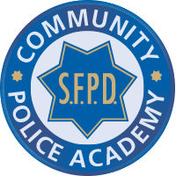

San Francisco Community Police Academy
Course Application

Thank you for your interest in the Community Police Academy. Please complete the information requested below, as a computer check of your information will be conducted. Also, please let us know why you want to participate in this training program. Once your application is reviewed you will be notified by email or mail if you are selected to participate.

If you have any questions please email us at sfpd.cpa@sfgov.org.

All candidates must meet the following criteria:
- Minimum age of 18 years
- Live or work in San Francisco
- No Felony convictions
- No Misdemeanor convictions within one year of application
- Candidates are expected to attend all classes.

Please complete the following information:

Legal Full Name: Click here to enter text.
Email: Click here to enter text.
Address: Click here to enter text.
City: Click here to enter text. State & Zip Code: Click here to enter text.
Occupation: Click here to enter text.
Driver’s Lic. # or CA I.D. #: Click here to enter text.
Home Phone: Click here to enter text.
Cell Phone: Click here to enter text.
DOB: Click here to enter text.

PLEASE SUBMIT A PARAGRAPH STATING WHY YOU WANT TO PARTICIPATE IN THIS TRAINING PROGRAM, ALONG WITH YOUR APPLICATION TO:
YCEU Community Police Academy Coordinator
San Francisco Police Headquarters
1245 3rd Street, 5th Floor
San Francisco, CA 94158

